SQL QUERIES AND THE RESULT FOR BANK CREDIT CARD CHURN CUSTOMERS

- Important KPI’s
# 1. Total customers:
SELECT COUNT(*) AS Total_Customers FROM churn_modelling;
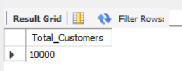
# 2. Total churned customers:
SELECT COUNT(*) AS Total_Churned_Customers FROM churn_modelling WHERE Exited = 1;
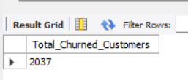
# 3. Churn rate:
SELECT ROUND( (SUM(CASE WHEN Exited = 1 THEN 1 ELSE 0 END) / COUNT(*)) * 100, 2 ) AS Churn_Rate_Percentage FROM churn_modelling;
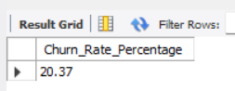
# 4. Avg account balance:
SELECT ROUND(AVG(Balance), 2) AS Average_Account_Balance FROM churn_modelling;
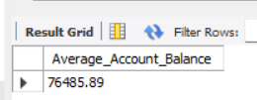

# 5. Active customer rate:
SELECT ROUND((SUM(CASE WHEN IsActiveMember = 1 THEN 1 ELSE 0 END) / COUNT(*))* 100, 2) AS Active_Customer_Rate FROM churn_modelling;
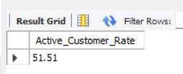
# 6. Credit card ownership rate:
SELECT ROUND((SUM(CASE WHEN HasCrCard = 1 THEN 1 ELSE 0 END) / COUNT(*)) * 100,2) AS Credit_Card_Ownership_Rate FROM churn_modelling;
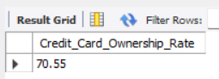
- Other KPI’s
# 1. Avg age:
SELECT ROUND(AVG(Age), 2) AS Avg_Age FROM churn_modelling;
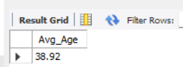
# 2. Avg credit score:
SELECT ROUND(AVG(CreditScore), 2) AS Avg_Credit_Score FROM churn_modelling;
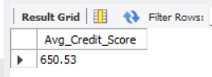
# 3. Avg tenure:
SELECT ROUND(AVG(Tenure), 2) AS Avg_Tenure FROM churn_modelling;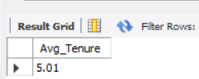

# 4. Avg salary:
SELECT ROUND(AVG(EstimatedSalary), 2) AS Avg_Estimated_Salary FROM churn_modelling;
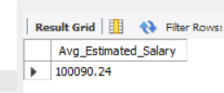

# 5. Total exited:
SELECT COUNT(*) AS Total_Exited
FROM churn_modelling
WHERE Exited = 1;
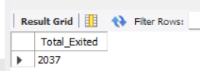

# 6. Customer with credit card:
SELECT
SUM(CASE WHEN HasCrCard = 1 THEN 1 ELSE 0 END) AS Customers_With_Card,
ROUND(SUM(CASE WHEN HasCrCard = 1 THEN 1 ELSE 0 END) / COUNT(*) * 100, 2 ) AS With_Card_Percentage FROM churn_modelling;
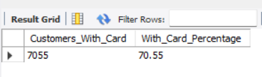

# 7. Active customers:
SELECT
SUM(CASE WHEN IsActiveMember = 1 THEN 1 ELSE 0 END) AS Active_Customers,
ROUND(SUM(CASE WHEN IsActiveMember = 1 THEN 1 ELSE 0 END) / COUNT(*) * 100, 2 ) AS Active_Customers_Percentage FROM churn_modelling;
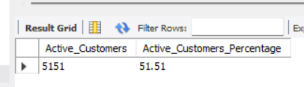

# 8. Avg number of products:
SELECT ROUND(AVG(NumOfProducts), 2) AS Avg_Num_Products FROM churn_modelling;
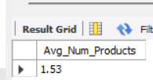

# 9. Exited customer by gender:
SELECT
Gender,COUNT(*) AS Exited_Customer FROM churn_modelling WHERE Exited = 1 GROUP BY Gender;
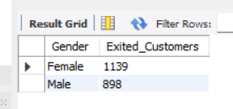

# 10. Total number of exited customers:
SELECT
Exited,
COUNT(*) AS Num_Customers FROM churn_modelling GROUP BY Exited;
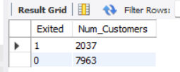

# 11. Count of customers by balance and exited:
SELECT
CASE
WHEN Balance < 50000 THEN 'Low (<50k)'
WHEN Balance BETWEEN 50000 AND 100000 THEN 'Medium (50k-100k)'
ELSE 'High (>100k)'
END AS Balance_Range,
Exited,
COUNT(*) AS Num_Customers FROM churn_modelling GROUP BY Balance_Range, Exited
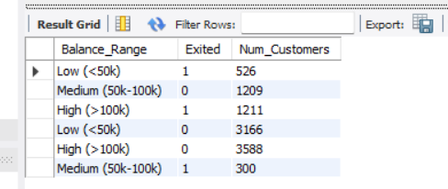

# 12. Customer churn by number of products:
SELECT
NumOfProducts,
COUNT(*) AS Total_Customers,
SUM(CASE WHEN Exited = 1 THEN 1 ELSE 0 END) AS Exited_Customers,
ROUND(SUM(CASE WHEN Exited = 1 THEN 1 ELSE 0 END) / COUNT(*) * 100, 2 ) AS Churn_Rate_Percentage FROM churn_modelling GROUP BY NumOfProducts ORDER BY NumOfProducts;
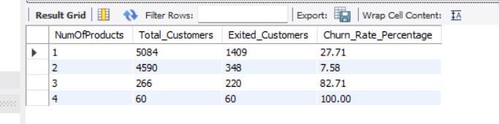
# 13. Customer by country count and churn:
SELECT
Geography,
COUNT(*) AS Total_Customers,
SUM(CASE WHEN Exited = 1 THEN 1 ELSE 0 END) AS Exited_Customers,
ROUND(SUM(CASE WHEN Exited = 1 THEN 1 ELSE 0 END) / COUNT(*) * 100, 2) AS Churn_Rate_Percentage FROM churn_modelling GROUP BY Geography ORDER BY Geography
